JUNIOR
Do you like to jam out and dance to your favorite music? Then this is the club for you! Join Miss Shepherd and Ms. Gorka on a cultural, dance exploration with fun kid-friendly dances, activities and games!
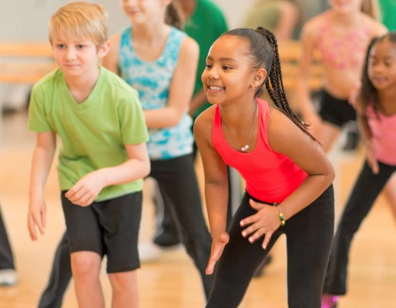
https://www.zumba.com/en-US/party

Who: Desmares students in grades 1 and 2
When: Wednesdays 3:45-4:30
Wednesday October 19th, 26th and November 2nd, 9th
Cost: $25 Please pay by check made out to Desmares PTO with “Zumba Kids Junior Club” on the memo line.

This club is limited to 25 students. A confirmation slip will be sent
home either way so that your child knows if he/she is in the club.

*Students may bring a nut-free snack to eat before club begins at 3:30
TRANSPORTATION IS NOT PROVIDED!

--------------------------------------------------------------------------------------------------------
RETURN THIS SECTION AND A CHECK (made out to Desmares PTO) in an envelope to Ms. Gorka’s mailbox by Friday, October 7th.

Student’s Name:_______________________________________________________________________________________

Teacher:________________________________________________________________________________________________

Bus Number:___________________________________________________________________________________________

Parent’s Name and Number:__________________________________________________________________________

Emergency Contact Name and Number:_____________________________________________________________

Parent Signaure:_______________________________________________________________________________________

